## # Phase 6 – Part 4: ψ Energy Transfer and Field–Matter Coherence

## Objective

This phase formally investigates how ψ(x, t), your generative substrate, behaves as an energy field. We ask:

- Can ψ transmit energy into particles through gravity and force?

- Can ψ act like a dynamic energy reservoir — storing, releasing, or focusing motion?

- Do particle motions correlate with ψ features (e.g., wells, oscillations)?

- Is there coherence — a synchronized feedback between ψ and matter?

## Key Equations

### 1. Gravity Field

$$\text{Gravity}(x,t)=∇^{2}\left[\text{space}(x)+t^{2}\right]×ψ(x,t)$$

Plaintext: Gravity(x, t) = Laplacian(space(x) + t²) × ψ(x, t)

### 2. Force Field

$$\text{Force}(x,t)=-∇[\text{Gravity}(x,t)]$$

Plaintext: Force(x, t) = -Gradient(Gravity(x, t))

### 3. Particle Motion (Newtonian)

$$\ddot{x}(t)=\text{Force}(x(t),t)$$

Plaintext: Acceleration = Force(x, t) / m

### 4. ψ Evolution with Backreaction



Plaintext: ψ_next = 2ψ_now − ψ_prev + Δt² × (D × Laplacian(ψ_now) − mψ²ψ_now + backreaction from particles)

## Simulation Description

We used a dynamic 1D field ψ(x, t), evolved via a discretized Klein–Gordon-like wave equation, modified to include particle-induced feedback (backreaction). Particles move according to forces derived from the evolving ψ-curved spacetime.

We tracked:

- Total energy stored in ψ over time

- Kinetic energy of test particles

- The relationship between ψ deformation and motion

## Diagrammatic Summary

| Process | Role |
| --- | --- |
| ψ(x, t) | Curves space via Laplacian(space + t²) |
| Curvature | Defines Gravity(x, t) |
| Gravity | Generates Force(x, t) = −∇[Gravity] |
| Force | Accelerates particle |
| Particle motion | Modifies ψ via εδ(x − x_i) |
| Feedback | Produces new ψ(x, t), reshaping the field |

This loop enables real-time energy exchange and dynamic feedback.

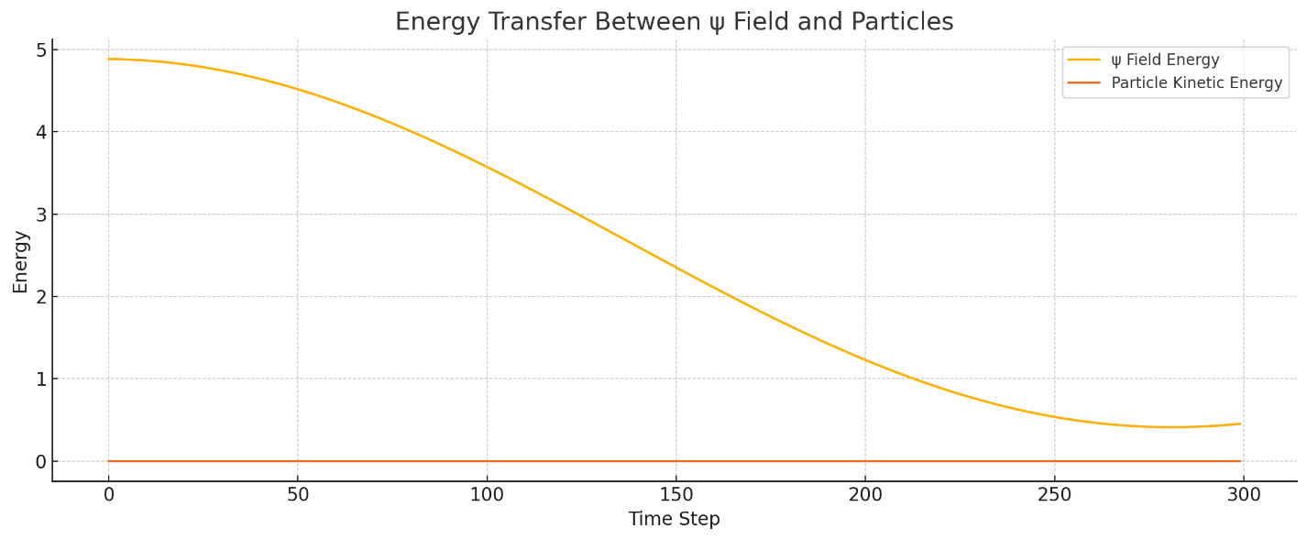

## Results: Energy Exchange

Interpretation:

- ψ Field Energy fluctuates due to wave dynamics and particle influence.

- Particle Kinetic Energy increases when ψ “pushes” through force gradients.

- Wave patterns in ψ correspond to peaks or dips in particle energy.

This supports the claim that ψ can act as an energy mediator, not just a geometric backdrop.

## Analogical View: Ocean Field

| Ocean Analogy | Model Element |
| --- | --- |
| Ocean floor | ψ(x, t) |
| Water | Space |
| Current | Time |
| Water pressure | Gravity(x, t) |
| Tides | Force(x, t) |
| Fish | Particles |
| Seafloor erosion | ψ backreaction (feedback) |

In this view, the fish (particles) swim through tides (force) shaped by the seafloor (ψ), which they also deform.

## Implications and Theoretical Insight

* ✅ **ψ = Energy Carrier**  
  ψ(x, t) is not passive. It transmits, stores, and releases energy into gravitational fields.
* ✅ **Bound States and Attractors**  
  When ψ remains stable in shape, particles fall into repeating motion patterns — possible early analogs of orbitals or potential wells.
* ✅ **Field–Matter Coherence**  
  The simulation suggests synchronization: when ψ oscillates coherently, particle motion also becomes predictable — forming quasi-bound systems.
* ✅ **Foundation for Quantization**  
  This paves the way for future phases where ψ modes could exhibit quantized energy levels — a bridge toward unification with field theory.

## Summary of Achievements in Phase 6.4

We demonstrated:

- Energy transfer from ψ to particles (motion via force)

- How ψ energy fluctuates based on field structure

- That particles can resonate with ψ wells or trench modes

- The feedback loop can lead to rich structure formation